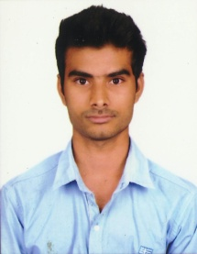
SHARMA MUKKAVILLI

Email: harishsharma547@gmail.com

Contact No: +91-7893 427 724

Objective

Socially savvy individual interested in a Marketing Executive position that will utilize business and management education and organizational and communications skills to effective marketing presentations.

Education
- Pursuing MBA (Marketing & Finance) in MVGR College of Engineering (A) with an aggregate of 80.75% (8.50 CGPA points).
- B.Tech (Computer Science & Engineering) in 2013 from Al-Aman College of Engineering with an aggregate of 61.94%
- Intermediate (M.P.C) in 2009 from Vikas Junior College with an aggregate of 76.8%
- SSC in 2007 from Gnan Vikas Vidyaniketan with an aggregate of 71.83%

Experience
  - Worked as a Graduate Trainee in Hindustan Shipyard Limited, Visakhapatnam (December – 2013 to December – 2014).
  - Worked as a Process Executive in Patra (India) BPO services, Visakhapatnam (December – 2014 to August – 2015).

Achievements & Honors
  - Participation certificate for “National fest” in Integral Institute of Advanced Management (IIAM Vizag).
  - Stood top five in academics in all the three semesters of MBA.
  - First prize in group power point presentation on “Worldcom Scam” in MVGR College of Engineering (Autonomous)
  - Participation certificate for “Personality Development and Employability Skills” in Andhra University.
  - Second prize in paper presentation on “5G mobile technology” in Al-Aman College of Engineering.

Presentations
- Power point presentation on Worldcom Scam.
- Power point presentation on 5G (5th Generation Mobile Technology).
- Power point presentation on Gi-Fi (Gigabyte Fidelity).

Evaluation
- Good people management. Team player
- Able to work under high pressure and time limitation
- Responsible
- With good management skills and organizational capabilities

Interests
- Making new friends
- Making animations to power point presentations

Project

Name: Retail Management of “Visakha Book Store”
Duration: 2 weeks
Description:
This mini project is mainly deals with a book store to know the details about their retailing strategies, pricing strategies, customer service and competitive advantage.

Personal Profile
Full Name | MUKKAVILLI NVKRAH SHARMA
Date Of Birth | 17th August, 1992
Age | 24
Languages Known | Telugu, English, Hindi
Nationality & Religion | INDIAN & Hindu
Hobbies | Playing Chess, Listening Music, Reading Novels & Solving Jigsaw Puzzles
Address for Communication | Door No: 62-3-101,  New Ramalayam 2nd Street,  Sriharipuram,  Visakhapatnam-530 011.
Declaration
I hereby declare that the information and facts stated above are true and correct to the best of my knowledge and belief.
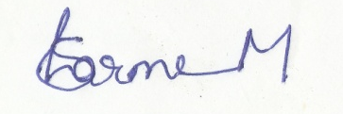
Place: Visakhapatnam

Date: (SHARMA M)

